Test Case: tc002_SPX_Dev5_Crear_Requisicion_Spot_Tipo_Cobro_Project
Step 1 - Enter username and password and click to button Enter: Credentials Entered
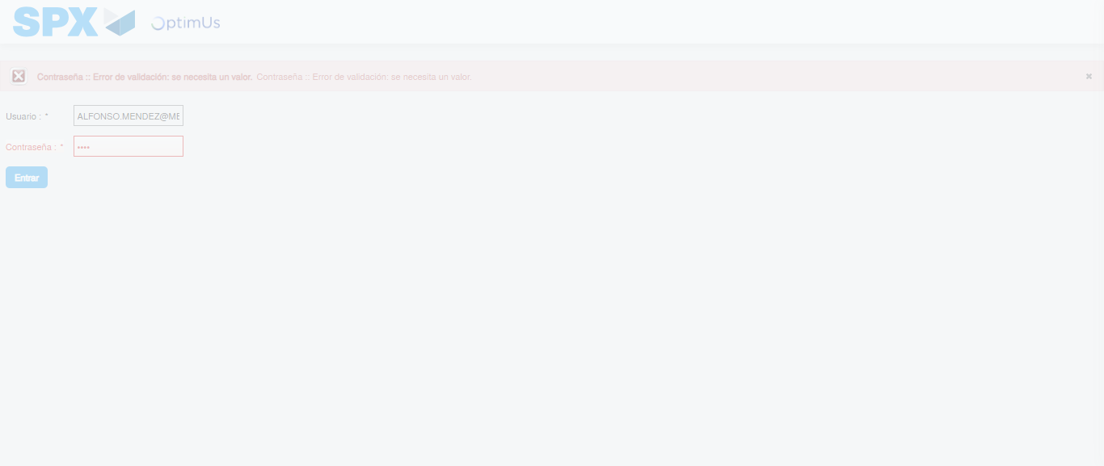Image file-name: QC_Testing-tc002_SPX_Dev5_Crear_Requisicion_Spot_Tipo_Cobro_Project-1783361297385

Step 2 - Select to UEN and Access to Spot Buy Requisitions : UEN Correctly selected and Correct access
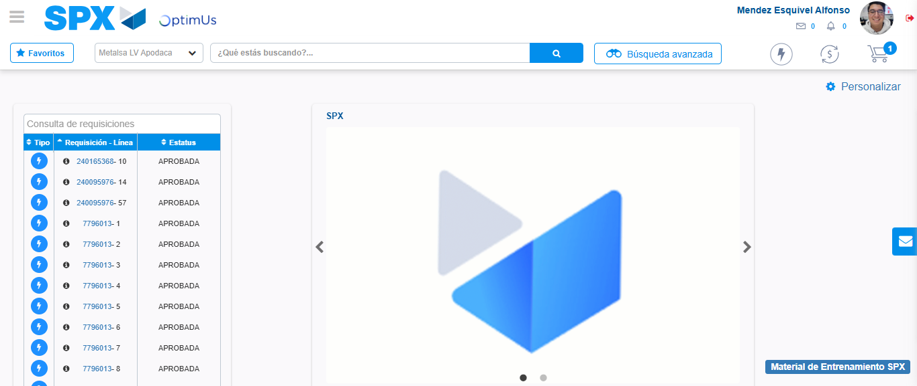Image file-name: QC_Testing-tc002_SPX_Dev5_Crear_Requisicion_Spot_Tipo_Cobro_Project-1783361322512

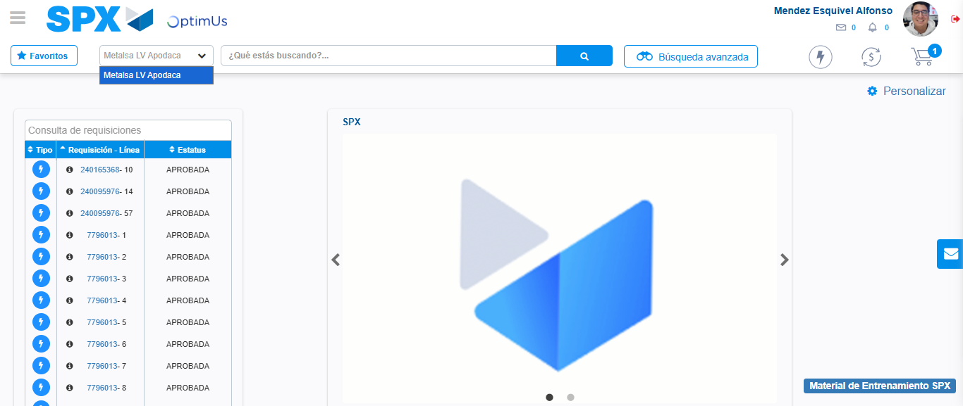Image file-name: QC_Testing-tc002_SPX_Dev5_Crear_Requisicion_Spot_Tipo_Cobro_Project-1783361325216

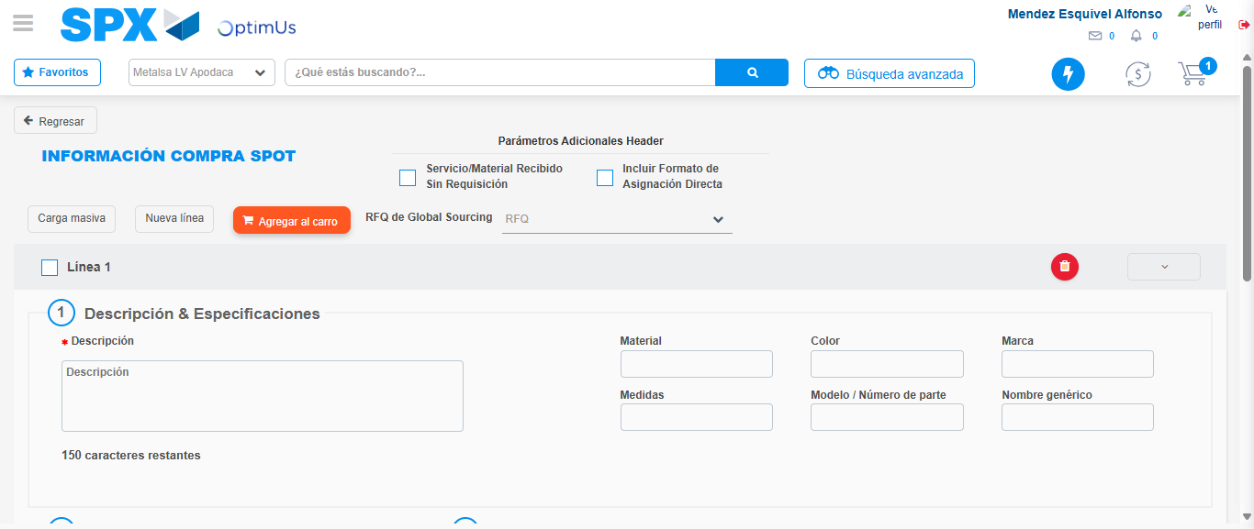Image file-name: QC_Testing-tc002_SPX_Dev5_Crear_Requisicion_Spot_Tipo_Cobro_Project-1783361349785

Step 3 - Data Capture Spot Buy Requisition: Data captured correctly
Image file-name: QC_Testing-tc002_SPX_Dev5_Crear_Requisicion_Spot_Tipo_Cobro_Project-1783361350109

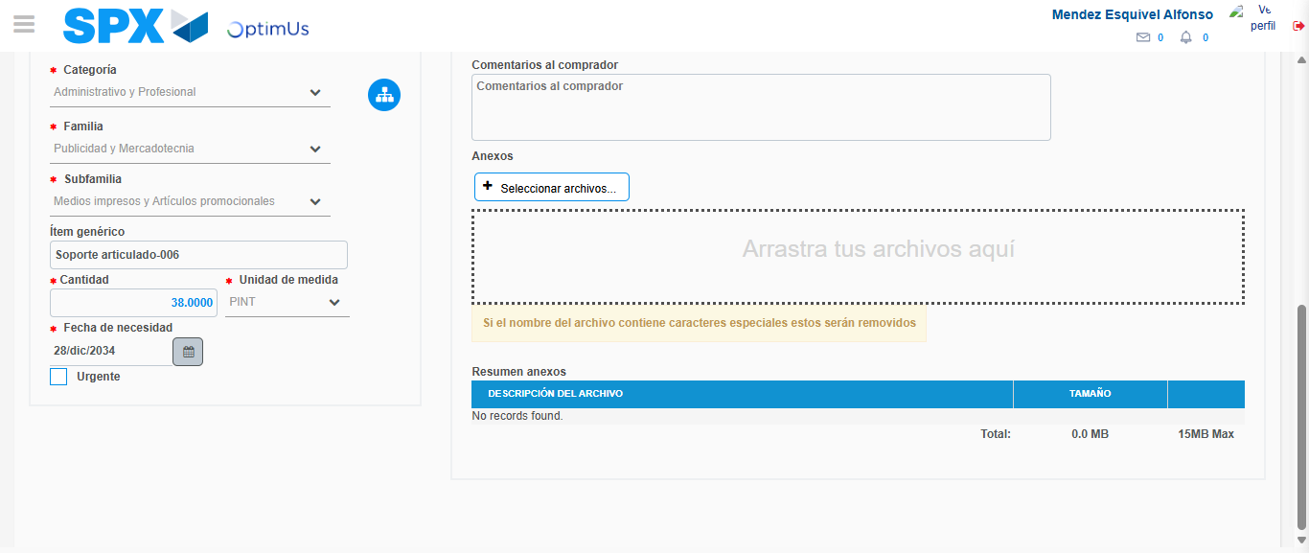Image file-name: QC_Testing-tc002_SPX_Dev5_Crear_Requisicion_Spot_Tipo_Cobro_Project-1783361362760

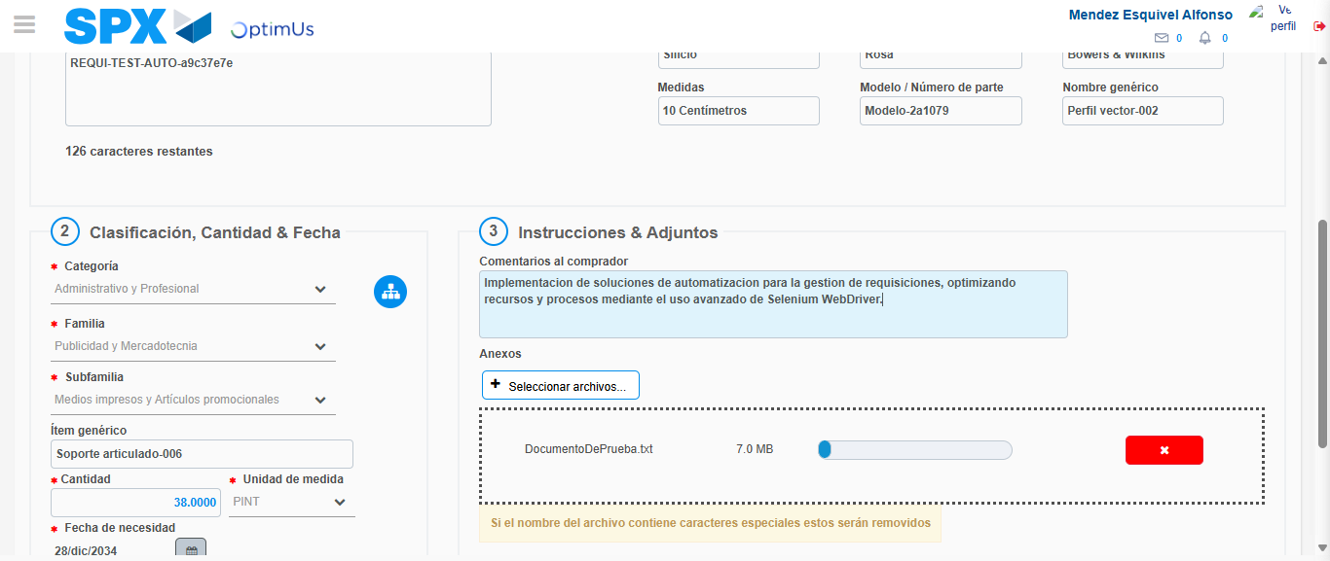Image file-name: QC_Testing-tc002_SPX_Dev5_Crear_Requisicion_Spot_Tipo_Cobro_Project-1783361363777

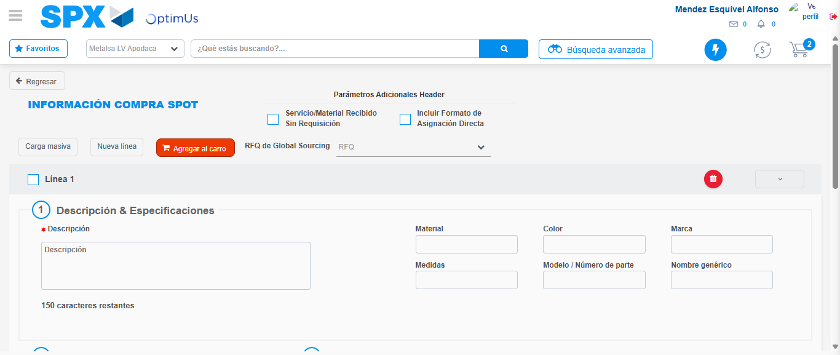Image file-name: QC_Testing-tc002_SPX_Dev5_Crear_Requisicion_Spot_Tipo_Cobro_Project-1783361369406

Step 7 - Return to Main Page SPX : Return to Main Page SPX
Image file-name: QC_Testing-tc002_SPX_Dev5_Crear_Requisicion_Spot_Tipo_Cobro_Project-1783361322512

Image file-name: QC_Testing-tc002_SPX_Dev5_Crear_Requisicion_Spot_Tipo_Cobro_Project-1783361325216

Image file-name: QC_Testing-tc002_SPX_Dev5_Crear_Requisicion_Spot_Tipo_Cobro_Project-1783361349785

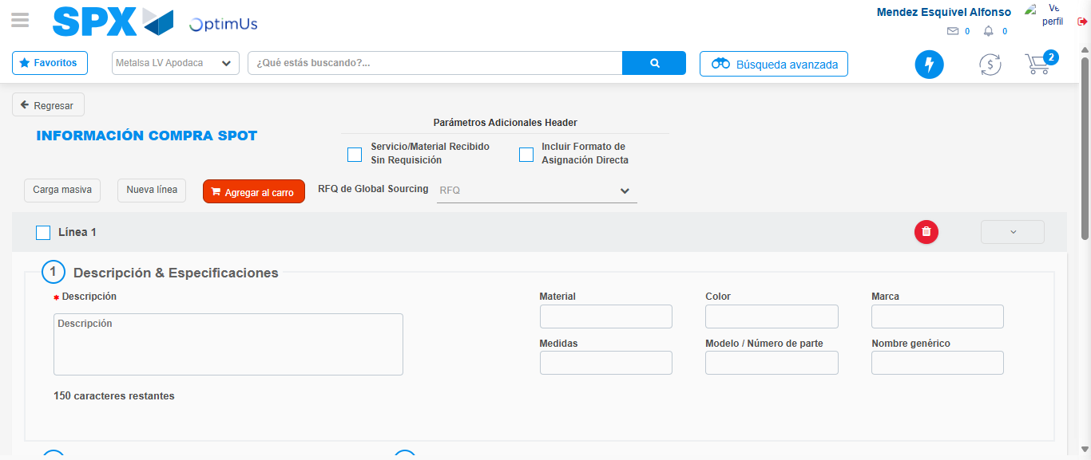Image file-name: QC_Testing-tc002_SPX_Dev5_Crear_Requisicion_Spot_Tipo_Cobro_Project-1783361371660

Image file-name: QC_Testing-tc002_SPX_Dev5_Crear_Requisicion_Spot_Tipo_Cobro_Project-1783361371857

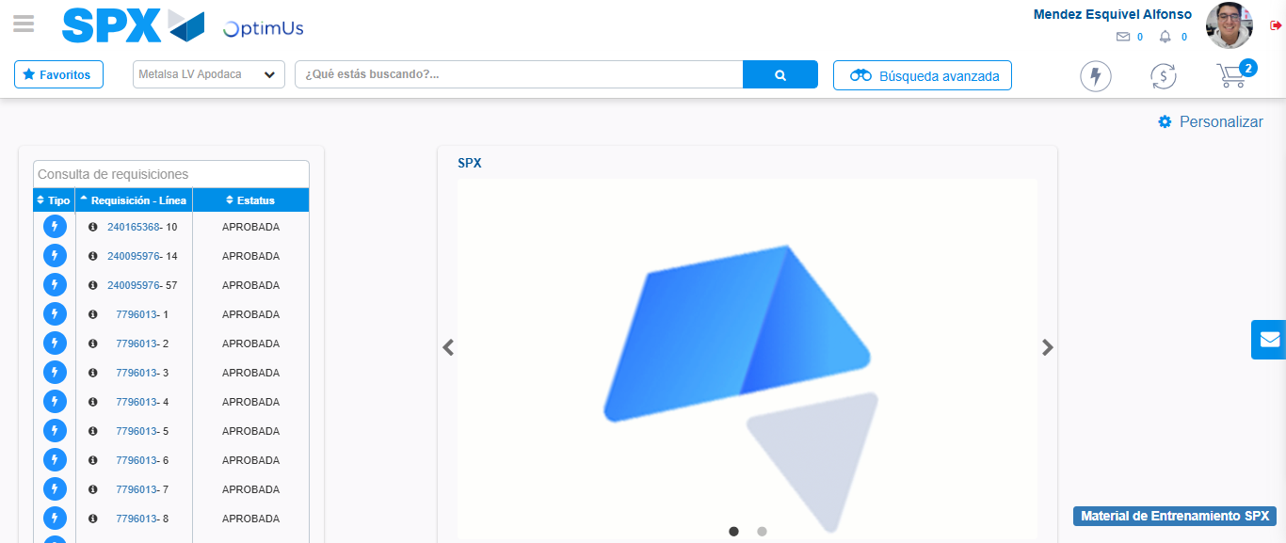Image file-name: QC_Testing-tc002_SPX_Dev5_Crear_Requisicion_Spot_Tipo_Cobro_Project-1783361393063

Step 8 - Log Out : Log Out SPX
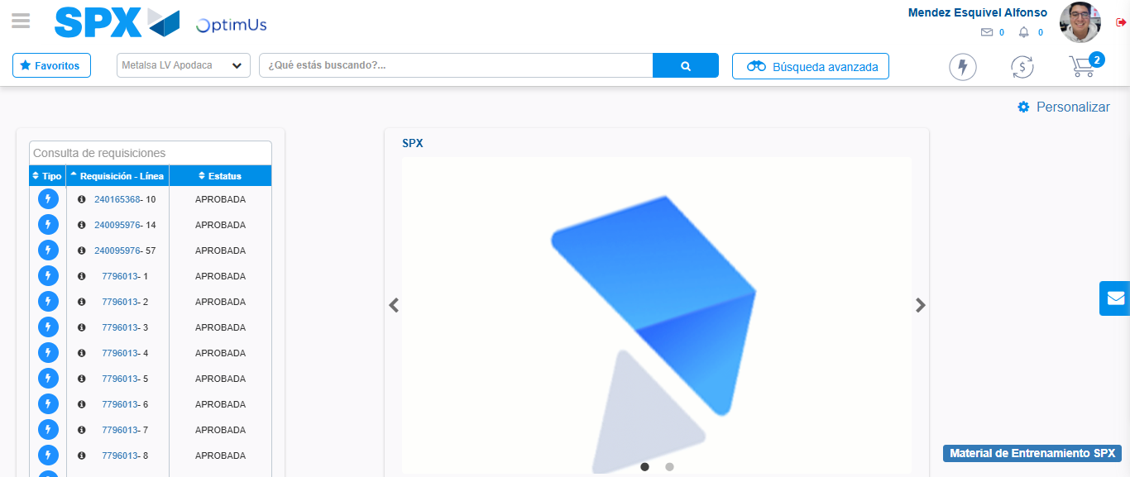Image file-name: QC_Testing-tc002_SPX_Dev5_Crear_Requisicion_Spot_Tipo_Cobro_Project-1783361393328

